Microsoft Azure - Starter Kits for Partners

Statement of Work (Sample)

Backup and Archiving Scenario

Last Update: September 2015





**MICROSOFT MAKES NO WARRANTIES, EXPRESS, IMPLIED OR STATUTORY, AS TO THE INFORMATION IN THIS DOCUMENT.**

The information contained in this document represents the current view of Microsoft Corporation on the issues discussed as of the date of publication. Because Microsoft must respond to changing market conditions, it should not be interpreted to be a commitment on the part of Microsoft, and Microsoft cannot guarantee the accuracy of any information presented after the date of publication.

Complying with all applicable copyright laws is the responsibility of the user. Without limiting the rights under copyright, no part of this document may be reproduced, stored in or introduced into a retrieval system, or transmitted in any form or by any means (electronic, mechanical, photocopying, recording, or otherwise), or for any purpose, without the express written permission of Microsoft Corporation.

Microsoft may have patents, patent applications, trademarks, copyrights, or other intellectual property rights covering subject matter in this document. Except as expressly provided in any written license agreement from Microsoft, the furnishing of this document does not give you any license to these patents, trademarks, copyrights, or other intellectual property.

The descriptions of other companies’ products in this document, if any, are provided only as a convenience to you. Any such references should not be considered an endorsement or support by Microsoft. Microsoft cannot guarantee their accuracy, and the products may change over time. Also, the descriptions are intended as brief highlights to aid understanding, rather than as thorough coverage. For authoritative descriptions of these products, please consult their respective manufacturers.

© 2015 Microsoft Corporation. All rights reserved. Any use or distribution of these materials without express authorization of Microsoft Corp. is strictly prohibited.

Microsoft and Windows are either registered trademarks of Microsoft Corporation in the United States and/or other countries.

The names of actual companies and products mentioned herein may be the trademarks of their respective owners.

Contents

Overview 1

Scenario Overview 1

Why Backup and Archiving on Microsoft Azure? 1

Backup from on-premises 1

Backup from Microsoft Azure 1

The Proposed Solution 1

Azure Infrastructure Estimated Price 1

Fee Schedule 1

Scope of Work 1

Areas Out of Scope 1

Period of Performance 1

Engagement Resources 1

[Company Name] Project Roles and Responsibilities 1

Customer Project Roles and Responsibilities 1

Delivery Methodology 1

Deliverable Materials 1

General Customer Responsibilities and Project Assumptions 1

General Customer Responsibilities 1

Project Assumptions 1

Conditions of Satisfaction 1

Suggested Sections/Topics to be added by the Partner 1

# Overview

The purpose of this document is to provide Microsoft Partners with a **sample** Statement of Work (SOW) that they can use as a reference to propose to their customers an engagement for deploying an Azure Backup and Archiving Scenario.

Although this sample aims at facilitating and accelerating your engagements, Microsoft makes no warranty that using this template will result in a successful project, you are responsible for defining the conditions of satisfaction with your customer and delivering the proposed scenario.

In this document, we cover the following topics:

* SOW CONTRACT TEMPLATE
* THE PROPOSED SOLUTION
* FEE SCHEDULE
* SCOPE OF WORK
* AREAS OUT OF SCOPE
* PERIOD OF PERFORMANCE
* ENGAGEMENT RESOURCES
* DELIVERY METHODOLOGY
* DELIVERABLE MATERIALS
* GENERAL CUSTOMER RESPONSIBILITIES AND PROJECT ASSUMPTIONS
* CONDITIONS OF SATISFACTIOM

|  |  |
| --- | --- |
| [Company Name]  [Company Address] [City, ST ZIP Code] | Logo |

SOW [000] for Agreement to Perform Consulting Services to [Client Name]

Statement of Work

|  |  |  |
| --- | --- | --- |
| Date | Services Performed By: | Services Performed For: |
| [Date] | [Company Name]  [Company Address] [City, ST ZIP Code] | [Client Name]  [Client Address] [City, ST ZIP Code] |

|  |  |
| --- | --- |
|  | Placeholders for your content that appear in the paragraph text are shown in red and will change to the default text color when you add your content. Information that repeats in the document (such as client name) will be updated in all locations when you add or edit it once.  The text provided is sample SOW text that you can edit as applicable for your business.  Note: to delete any tip, such as this one, just click the tip text and then press the spacebar. |

This Statement of Work (SOW) is issued pursuant to the Consultant Services Master Agreement between [Client Name] (“Client”) and [Company Name] (“Contractor”), effective [Click to select date] (the “Agreement”). This SOW is subject to the terms and conditions contained in the Agreement between the parties and is made a part thereof. Any term not otherwise defined herein shall have the meaning specified in the Agreement. In the event of any conflict or inconsistency between the terms of this SOW and the terms of this Agreement, the terms of this SOW shall govern and prevail.

This SOW # [000] (hereinafter called the “SOW”), effective as of [Click to select date], is entered into by and between Contractor and Client, and is subject to the terms and conditions specified below. The Exhibit(s) to this SOW, if any, shall be deemed to be a part hereof. In the event of any inconsistencies between the terms of the body of this SOW and the terms of the Exhibit(s) hereto, the terms of the body of this SOW shall prevail.

In this project, [Company Name] (“Contractor”) will assist you with building a Archiving and Backup solution in Microsoft Azure.

This solution delivers a Backup Environment running in Microsoft Azure. [Company Name] Will assist in the design, deployment, and integration of the solution and leads solution walk through with customer staff.

# Scenario Overview

## Why Backup and Archiving on Microsoft Azure?

Microsoft Azure enables you to backup and archiving workloads, at reduced cost, and with the flexibility to backup and archiving from on-premises or in the cloud.

### Backup from on-premises

The cloud significantly alters the economics of backup making it possible for organizations to use Microsoft Azure to establish an option for recovery. This can be done at a fraction of the cost of building and maintaining a local datacenter.

Physical hardware (for example drives, servers, and network devices) can all fail and resources can be exhausted when load spikes. Microsoft Azure provides a recovery option under a backup strategy defined.

### Backup from Microsoft Azure

Applications can have bugs which corrupt data and operators can incorrectly delete important data. Microsoft Azure provides for backing up data and restoring to a previous point it time using the storage capabilities or adding backup tools as an Infrastructure as a Service.

**Summary**:

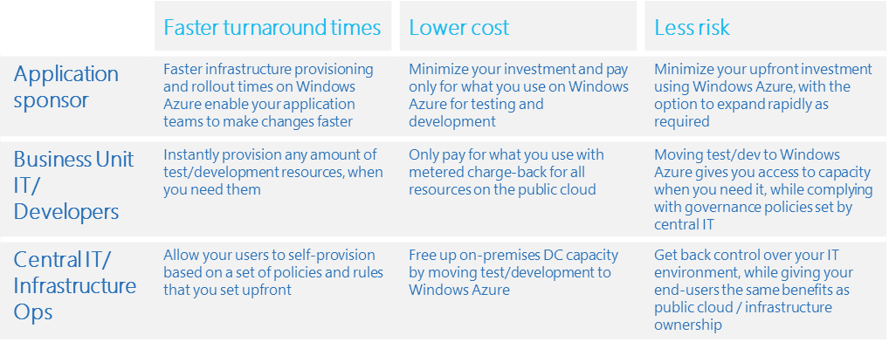

# The Proposed Solution

You can leverage Azure in your Backup Strategy for several workloads, such as **Windows Client, Windows Server, SQL Server, Exchange, SharePoint, Hyper-v**, and many other.

For this engagement, we are covering a Backup Lab infrastructure Integrating Microsoft Azure Backup with System Center Data Protection Manager to extend the backup solution to the cloud.



## Azure Infrastructure Estimated Price

If your company owns a MSDN subscription, you can enjoy up to $150 in credits on Azure with reduced Windows Server rates and use your MSDN software such as SQL Server for no **additional licensing fee**.

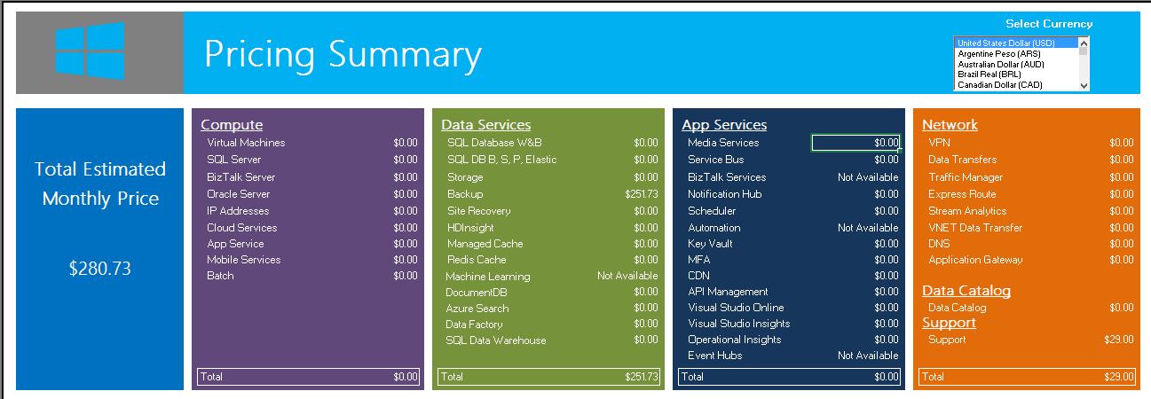

# Fee Schedule

This engagement will be conducted on a Time & Materials basis. The total value for the Services pursuant to this SOW shall not exceed [$000] unless otherwise agreed to by both parties via the project change control procedure, as outlined within. A PCR will be issued specifying the amended value.

# Scope of Work

In this project, [Company Name] (“Contractor”) will assist you with building a Backup solution in Microsoft Azure. This solution delivers a backup lab running in Microsoft Azure. [Company Name] Will assist in the design, deployment, and integration of the solution and leads solution walk through with customer staff.

**Note:** You can leverage Azure as the infrastructure of your Backup and Archiving Solution. For this engagement, we are covering a Backup Lab for on-premises workloads using System Center Data Protection Manager (DPM). We consider the DMP Server is already installed for this engagement.

|  |  |
| --- | --- |
| Work Item | Scope |
| General technical deployment guidance provided by [Company Name] | |
| Activities/Tasks | 1. Envision    * Pre-project preparation    * Project kickoff    * Microsoft Partner Technical Consultant Check-in 2. Plan    * Infrastructure design    * Review of existing backup infrastructure deployment    * Identify file data dependencies (applications, devices, standard drive mappings and automation dependencies)    * Update current backup strategy and routine according new approach    * Update architectural design templates according proposed Cloud Backup Solution    * Determine protection strategy for each workload: Backup agent or SCPDM?    * Document high-level data backup plan    * Func spec dev 3. Build    * Validate customer Azure account availability    * Enable and Configure Azure Connectivity, Storage Account and Backup Vaults    * Deploy and Configure Microsoft Azure Backup    * Create admin and co-admins    * Create an backup Vault    * Create and upload the x.509 v3 certificate    * Download and install Backup Agent    * Configure backup schedule and backup agent settings    * Validate recovery for Backup Agent strategy    * Deploy and Configure Microsoft Azure Backup with System Center 2012 - Data Protection Manager    * Installing the Microsoft Azure Backup Agent    * Register DPM Server    * Configure backup schedule and SCDPM settings    * Validate recovery for SCDPM strategy 4. Stabilize    * Validate Azure Backup, SCDPM and Azure Storage Installation    * Validate data storage and accessibility in Microsoft Azure Storage    * Validate backup and recovery functions    * Validate basic operations configuration (reporting, alerting, etc.)    * Knowledge Transfer / Demos to customer 5. Deploy    * Hand off to Operations    * Complete operational transition (configure monitoring, alerting, reporting, and data protection. Perform knowledge transfer and review support)    * Continue data protection efforts & turnover operational documentation to customer    * Project close out meeting |

# Areas Out of Scope

Any area that is not explicitly listed in section “Scope of Work” is out of scope for this engagement. The areas that are out of scope for this engagement include, but are not limited to, the following:

* Installation of System Center Data Protection Manager
* Overall program and project management.
* Management of customer resources.
* Creation of end-user communications, documentation, training, or change management.
* Support or assistance for implementing changes to customer identity provisioning processes.
* Technical change management approval process and supporting documentation.
* Microsoft Official Curriculum delivery.
* Configuration and deployment of the Site to Site VPN in the on premises datacenter.

INCLUDE MORE

# Period of Performance

The Services shall commence on [Click to select date], and shall continue through [Click to select date].

The total work, including, hands-on activities, technical meetings and answer to e-mails, is limited to a maximum of XXXX hours delivered remotely or on site during the course of the project

# Engagement Resources

### [Company Name] Project Roles and Responsibilities

|  |  |  |
| --- | --- | --- |
| Role | Responsibilities | Project Commitment |
| Engagement Manager | * Responsible for deliverable quality and Customer’s overall satisfaction * Single point of contact for billing issues, personnel matters, contract extensions, and project status * Stakeholder communication issue resolution and escalation | 2 hours / week |
| IT Consultant | * Responsible for planning and execution of solution | 40 hours / week |

### Customer Project Roles and Responsibilities

|  |  |  |
| --- | --- | --- |
| Role | Responsibilities | Typical Time Commitment |
| Customer Project Sponsor | * Makes key project decisions, assists in escalating unresolved issues, and clears project roadblocks | 2 hours / week throughout |
| Customer Project Manager | * Primary point of contact for * Responsible for managing and coordinating the overall project * Responsible for resource allocation, risk management, project priorities, and communication to executive management * Manages day-to-day activities of the project * Coordinates the activities of the team to deliver deliverables according to the project schedule | Full time during planning; approx. 10 hours |
| Infrastructure Lead | * Primary technical point of contact for the team that is responsible for technical architecture and code deliverables | Full time during planning; approx.. 28 hours  Part time during stabilize and deploy phases: approx. 12  4 hours during the Build phase |
| Lab Ops Lead | * Primary functional point of contact for the team that is responsible for functional use cases and operation of the solution | Full time during planning; 10 hours |

|  |  |
| --- | --- |
|  | List names of resources and any key information about each. |

# Delivery Methodology

Add here your delivery and project management methodology. Examples of engagement methodologies.

* Scrum
* Microsoft Solution Framework

Explain how you will divide the activities based on your methodology.

# Deliverable Materials

Include any deliverable you may leave behind after the deployment is completed. E.g.

* Documentation for Environment Configuration
* Architecture and Topology Documents
* PowerShell Scripts

|  |  |
| --- | --- |
|  | If this is an SOW for deliverable work product, describe deliverables here. If this is an SOW for services that do not include specific deliverables, you might want to include a statement such as “There are no formal deliverables or work products defined in association with these services.” |

# General Customer Responsibilities and Project Assumptions

## General Customer Responsibilities

Delivery of scoped items depends upon, among other things, the following:

* Customer’s involvement in all aspects of the services
* Customer’s ability to provide accurate and complete information, as needed
* Customer’s timely and effective completion of the responsibilities, as identified herein
* The accuracy and completeness of the Assumptions, identified below
* Timely decisions and approvals by Customer’s management
* Customer’s completion of site readiness activities (if applicable)

In addition to any Customer activities identified elsewhere in this SOW, Customer will perform or provide the following:

* Procure and provide access to required Azure subscriptions and capacity
* Provide written descriptions of lab use cases and scenarios
* Provide written diagrams and descriptions of the network topology connecting your datacenter to Azure
* Provide adequate bandwidth to Microsoft Azure and a Microsoft Azure supported to the backup jobs.
* Make any and all necessary network configuration changes required to facilitate connectivity to Microsoft Azure from your datacenter and the locations from which the lab users will be accessing it
* In performing services under this SOW and the applicable Work Order, Contractor will rely upon any instructions, authorizations, approvals, or other information provided by Customer’s Project Manager or personnel duly designated by Customer’s Project Manager.

## Project Assumptions

The Services, fees, and delivery schedule for this project are based on the following assumptions:

* Any and all hardware and software components utilized on-premises are Certified for Windows Server
* All software used in the lab solution is supported for usage in Microsoft Azure by Microsoft and the respective vendor (if produced by a 3rd party)
* Your lab workload performance, capacity, and density patterns follow commonly encountered industry trends or capacity estimates and designs are adjusted to accommodate them
* You own or procure all required software licenses and Azure subscriptions
* Throughout the project, Contractor will submit requests for decisions or feedback for Customer to complete. Decisions are assigned due dates, and it is assumed that Customer will provide the required feedback or make decisions on either the due date agreed upon or (3) business days from the date of submittal. If a decision or feedback is not provided within the due date or (3) business days, it will be addressed as a potential change of scope pursuant to the Change Management process outlined in this SOW.

|  |  |
| --- | --- |
|  | Define client responsibilities. |

Completion Criteria

The project will be considered complete when any of the following conditions are met:

1. All In Scope tasks are completed; or
2. All funding has been utilized for hours of services delivered and expenses incurred; or
3. The period of performance has expired; or
4. The Work Order is terminated pursuant to the provisions of the agreement.

# Conditions of Satisfaction

Add here the criteria that define the success of this engagement. E.g.

* Cost of backup solution is reduced by X %
* Time spent managing backup is reducing by X %
* Infrastructure Provisioning time for testing new application features is decreased **by X %**

# Suggested Sections/Topics to be added by the Partner

* Change Management Criteria